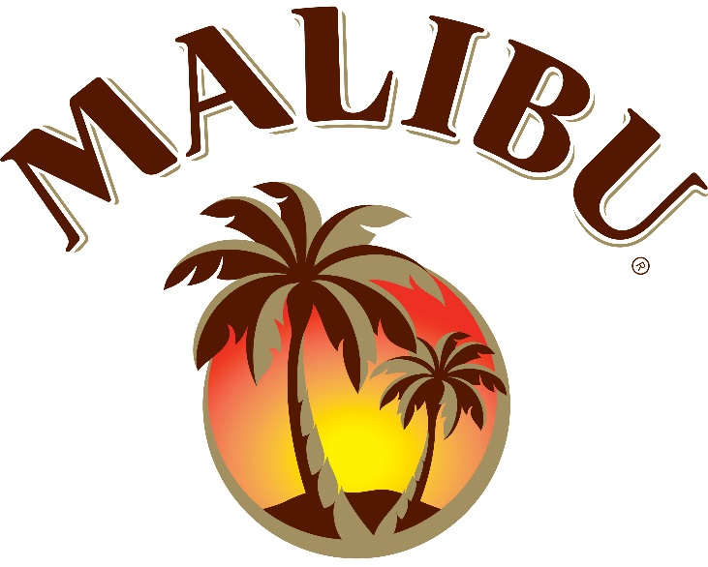

Malibu Chooses Isaac Morris Limited for North American Apparel

For Immediate Release
Media Contact:
Sayles & Winnikoff Communications
Contact: Elyse Staten
Phone: (212) 725-5200 ext. 114
Email: elyse@sayleswinnikoff.com

SAN FRANCISCO, May 11, 2017 - Dimensional Branding Group (DBG), a San Francisco Bay Area brand extension licensing agency and The Absolut Company, global owner of the Malibu brand, are announcing today Isaac Morris Limited (IML) as official apparel licensee for the Malibu brand for North America. The apparel line is set to launch in the third quarter of this year.

Elsa Rafen, global brand manager for Malibu, says, "We are thrilled to be partnering with IML to extend the Malibu brand into apparel in the US and further establish the Malibu summer lifestyle. Malibu is a global icon of summer. Known and loved in 150 markets, it brings the vibrant spirit of summer to life with its unique summer identity, iconic logo and white bottle.”

Milin Shah, Vice President and General Counsel for Isaac Morris Limited, “We are excited by the Malibu brand and its lifestyle POV. Our apparel line will emphasize the unique MALIBU character and bring it to life, with energetic designs that reflect the warm spirit of summer in a highly contemporary way”.
About Dimensional Branding Group, LLC:
The San Francisco Bay Area based brand extension agency that focuses on brand licensing, business development and promotion services with a unique emphasis on the interactive & digital channels. DBG specializes in developing toys & games, iconic brands & digital trademarks into entertainment placement and new extension markets. Its clients include King Kong, Talking Tom, Miniclip, Temple Run, Skee-Ball, Chronicle Books, Miniclip, Bob’s Space Racers, Bay Tek Games, Marlon Brando, John Wayne, Cookie Jam, Snoopy Pop, Malibu among others. www.dimensionalbranding.com
About Isaac Morris Limited: Founded in 1989, Isaac Morris Ltd has developed its business to become a leader in the apparel market. For over 20 years, IML has serviced retailers with top notch quality, art, and execution which has made us one of the top Licensed Apparel manufacturers in the industry! Specializing in Boys, Men’s, Girls, & Junior clothing, IML’s distribution ranges from Specialty stores, Department stores, & the Mass Market catering to each one in a unique way to service their needs properly. Based out of NYC with an in-house licensing & art team, IML is committed to representing each of their properties with some of the industry’s best artwork along with the latest trends.

About The Absolut Company: The Absolut Company has the worldwide responsibility for the production, innovation and strategic marketing of Absolut Vodka, Malibu, Kahlúa and Our/Vodka. Absolut Vodka is the world’s fifth largest spirits brand. Malibu is the number one rum-based coconut spirit in the world, sold in more than 150 countries. Kahlúa coffee liqueur is the world leader in its category. The head office is in Stockholm, Sweden. Chairman and CEO is Anna Malmhake. The Absolut Company is a part of Pernod Ricard, which holds one of the most prestigious brand portfolios in the sector.www.theabsolutcompany.com

